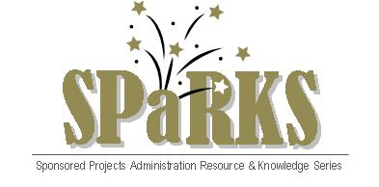

Module 10: Commercialization

August 17, 2011
Instructor: | Phone: | E-Mail:
Dr. Tom O’Neal  Dr. Svetlana Shtrom | 882-1120  823-5150 | oneal@ucf.edu  svetlana.shtrom@ucf.edu

Module Description
Overview of research commercialization and UCF’s role in stimulating innovation and economic growth in Central Florida.

Module Overview
The purpose of this module is to introduce SPaRKS participants to the process of research commercialization. This session will cover invention disclosure processing and intellectual property management. Participants will also learn about the resources and services available at UCF and the community that make up our region’s innovation ecosystem. Additionally, the session will recap the cyclical nature of research and the transfer of technology to market.

Module Objectives
- Participants will gain a better understanding of the process by which inventions are commercialized.
- Participants will learn about UCF’s role in accelerating innovation and economic growth.
- Participants will gain a better understanding of the supporting infrastructure that is necessary for successful transfer of technology and sustainable economic growth.
- Participants will gain a better understanding of the cyclical nature of award management.

